|  |  |  |  |
| --- | --- | --- | --- |
|  | **Bansilal Ramnath Agarwal Charitable Trust's**  **Vishwakarma Institute of Information Technology**  **Department of**  **Artificial Intelligence and Data Science** | | |
| Student Name: Siddhesh Dilip Khairnar | | | |
| Class: T.Y. | Division: B | | Roll No: 372028 |
| Semester: V | | Academic Year: 2023 - 24 | |
| Subject Name & Code: Cloud Computing and DevOps: ADUA31203 | | | |
| Title of Assignment: Write The shell scripting for demonstrate the following logic. 1) Decision Logic 2) Looping Logic 3) Decision and Looping Logic. | | | |
| Date of Performance: 30/08/2023 | | Date of Submission: 6/09/2023 | |

**Assignment: 2 (B)**

**Aim:** write shell scripting for looping and decision logic.

**Problem Statement:** Write The shell scripting for demonstrate the following logic.

1. Decision Logic
2. Looping Logic
3. Decision and Looping Logic.

**Theory:**

1. **Decision Logic:** Decision logic in shell scripting involves making choices or decisions based on certain conditions. The primary construct for decision-making in shell scripts is the if statement, which allows you to execute different blocks of code depending on whether a specified condition is true or false. Let’s break down the key components of decision logic in the context of shell scripting:

* **The if statement:** The if keyword marks the beginning of the decision block. It is followed by a condition that is enclosed in square brackets [].

* **Condition:** The condition is an expression that evaluates to either true or false. Common operators used in conditions include:
* -eq: Equal to

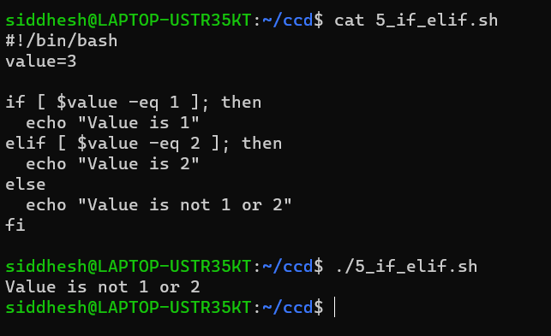

* -ne: Not equal to
* -lt: Less than
* -le: Less than or equal to
* -gt: Greater than
* -ge: Greater than or equal to
* **then keyword:** The then keyword follows the condition and marks the beginning of the code block that will be executed if the condition is true.
* **Code to execute if the condition is true:** This is the code that gets executed if the condition specified in the if statement evaluates to true. It should be indented for readability, although shell scripting is not as strict about indentation as some other programming languages.
* **The else keyword (optional):** The else keyword is used to define an alternative code block that is executed if the condition in the if statement is false. It's not required; you can have an if statement without an else block.
* **Code to execute if the condition is false:** This is the code that gets executed if the condition specified in the if statement evaluates too false. Like the code block for the true condition, it should also be indented.
* **The fi keyword:** The fi keyword marks the end of the if statement. It is used to close the decision block.

1. **Looping logic:** looping logic in shell scripting allows you to repeat a set of commands or actions multiple times. There are several types of loops in shell scripting, but the most used ones are the for loop and the while loop. Let's explore these loops in more detail:

* for Loop: The for loop is used to iterate over a range of values, a list of items, or a sequence. It repeats a block of code for each value in the specified range or list.

* while Loop: The while loop is used to repeat a block of code as long as a specified condition is true. It continues executing as long as the condition remains true.

1. **Decision and Looping Logic:** It’s referring to combining both decision-making (using if statements) and looping (using for or while loops) within a shell script. This combination allows you to create more complex scripts that perform iterative tasks based on certain conditions.

Conclusion: By understanding and effectively using decision and looping logic, we can create shell scripts that automate tasks, perform data processing, and solve a wide range of problems in a systematic and efficient manner. Shell scripting is a valuable skill for system administrators, developers, and anyone working in a Unix/Linux environment.